Name : Comments :

Group :

**Proposal/Report : Assignment 2 (Collaborative AI)**

________________________________________________________________________

**Instructions**

Create 2 FSMs ( minimum 3 state) each with trigger conditions (no key press) and responses.

Design the FSMs to support or help each other in team play through message boarding.

Each FSM( its object) should send 1 message and respond to 1 message.

Responses can be via HUDs and other forms of notification.

**Police FSM** States

Patrolling

Advancing

Taking Cover

Shooting

Going to Help

Helping

Dead

Become Leader

Conditions

Receive Message from Leader

Detect Robbers

Health Points less than amount

Distance to object

Leader dead?

State Transition Diagram

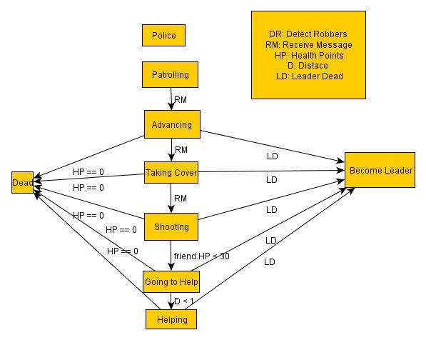

**Robber FSM** States

Stealing

Moving Money

Taking Cover

Escape

LookOut

Going to Help

Helping

Shooting

Dead

Conditions

Money in hand

Received Message

Distance from object

Detect Police

Health Point below something

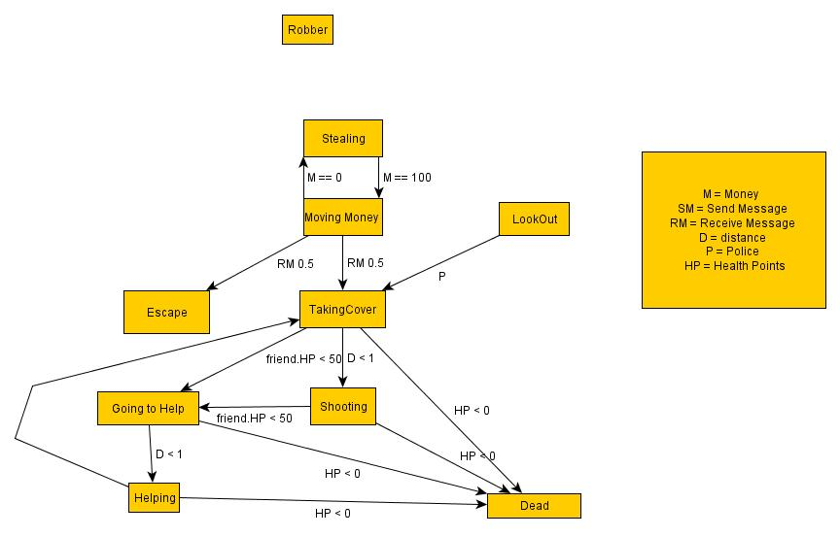

State Transition Diagram

Message Board

|  |  |  |  |  |
| --- | --- | --- | --- | --- |
| **Text** | **From** | **To** | **Response** | **Remarks** |
| Police are coming | Robber Lookout | Robber | Take Cover and run! |  |
| I see robbers in the bank! | Police | Police Leader | Everyone storm the bank! |  |
| Everyone take cover | Police Leader | Police | Taking Cover |  |
|  |  |  |  |  |
|  |  |  |  |  |
|  |  |  |  |  |